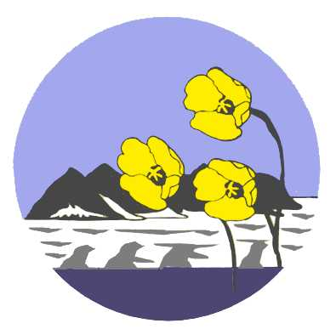
Registration form:
SvalbardGuideTraining (SGO)

Please send your completed form to: info@visitsvalbard.com

Name: _______________________

Date of birth: _______________________

Postal address: ________________________________________________________

Nationality: ________________________________________________________

Tel.: _______________________ E-mail: __________________

Person/company to be invoiced: _______________________________________________

Language skills (please mark with X)

◻ Norwegian/Swedish/Danish ◻ English ◻ German ◻ French ◻ Other ________

How long have you lived in Svalbard? From _______ To _______

I wish to participate in the following course(s):

Module 1: Svalbard Basic course _____________
Module 2: Svalbard Safety course _____________
Module 3: Svalbard Field course – summer _____________
Module 3: Svalbard Field course – winter _____________

Educational qualifications

Year | Educational institution | Subject | Title

Relevant work experience

Year | Employer | Position | Line of work

Relevant courses and certifications (in addition to SvalbardGuideTraining)

Year | Duration | Course | Organiser

Practice as guide in Svalbard - summer

Type of trip | Area for guiding | No. of people in the group | Duration

Practice as guide in Svalbard – winter

Type of trip | Area for guiding | No. of people in the group | Duration

General outdoor recreation experience

Type of trip | Duration | Area

Motivation, expectations and the guide’s role
It is important that you answer the following questions as thoroughly and honestly as possible.

Why are you applying for admission to SGO?

What do you expect to learn from SGO?

What knowledge and skills that you currently have do you believe will be useful in your work as a guide?

Where and how have you acquired the knowledge/skills?

What are your visions for the future regarding your guiding career? How long do you envisage you will work as a guide?

What limitations/challenges do you see in terms of making nature guiding your profession and livelihood?

What do you think can contribute to making nature guiding a realistic career option and livelihood for you?

